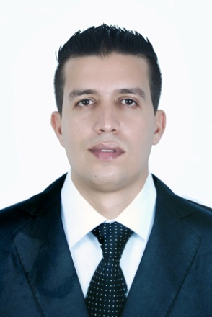
AMINE BADYE
27years
MOROCAN
Amine.badye@gmail.com

FORMATIONS

-2009/2010 : bachelor’s degree (natural sciences )
-2012/2014 : EMHTP school MOHAMEDIA of hotel and private tourisme
(flight attendant )
EXPERIENCES

- Receptionist at the Hotel Riad Mogador Essaouira for a month.
June 2013 (internship)
- Operations Officer at Ménara Marrakech Airport with ONDA for one
Months. June 2014 (internship)
- Extra 5 days from the organization of the World Women's Day in Meknes.
- Maintenance technician for 6 months at Anglo-BM-
Computing.
-technical manager at RIVAGE CAR five months February / June 2015
- Manager in REDA LAND hostel for 6 months.
-Mnager in RESTAURANT AMINE in Dakhla for 2 months.
-Waiter in SAHARA REGENCY hotel in DAKHLA one month.
-Waiter in IMPERIAL PLAYA hotel in DAKHLA one month .
LANGUAGES

-Frensh: reading, writing; spoken (well).
-English: reading; writing; spoken (medium).
-Spanish: basic notion.
-Arabic: kindergarten.

KNOWLEDGE

-Office: (word, excel, power point)
-Organization: plurie hottel, innova)
HOBBIES

-Surfing in the net .
-Playing sommes sports .
-Listen music .

